When users navigate to the site this is the homepage that should great them.

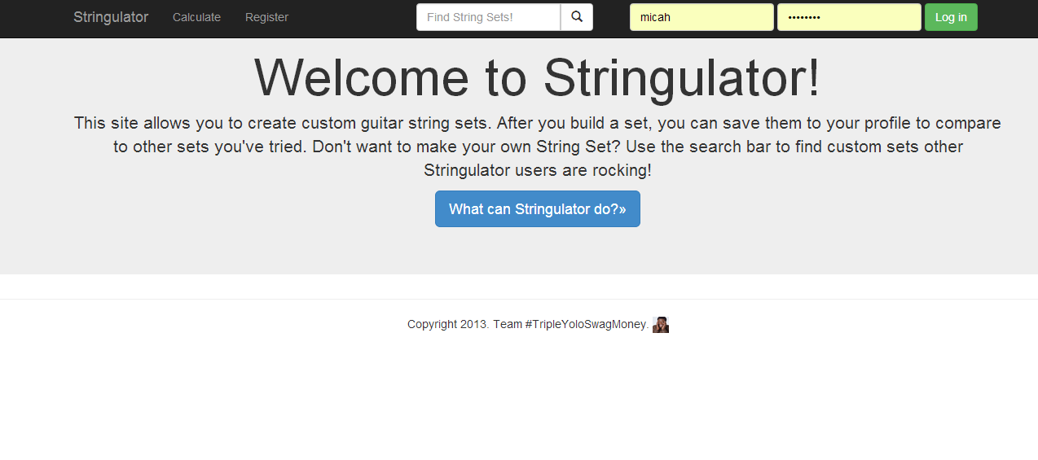

Type in a word to find string sets matched on that word.

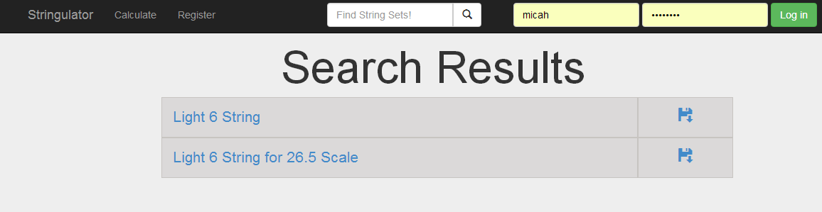

Click on a set to get it to pop up on the calculate page. In order to save the string set the user must be logged in. C:\Users\Micah\AppData\Local\Microsoft\Windows\INetCache\Content.Word\log in.png Or they will see the error message below. 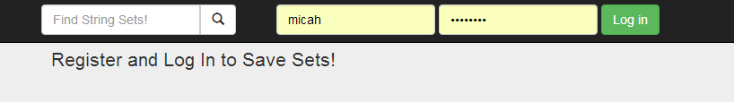

Similar error messages will be dispalyed if the user does not fill in the appropriate boxes with appropriate values.

Users can fill in the boxes and the tension will be dynamically added.

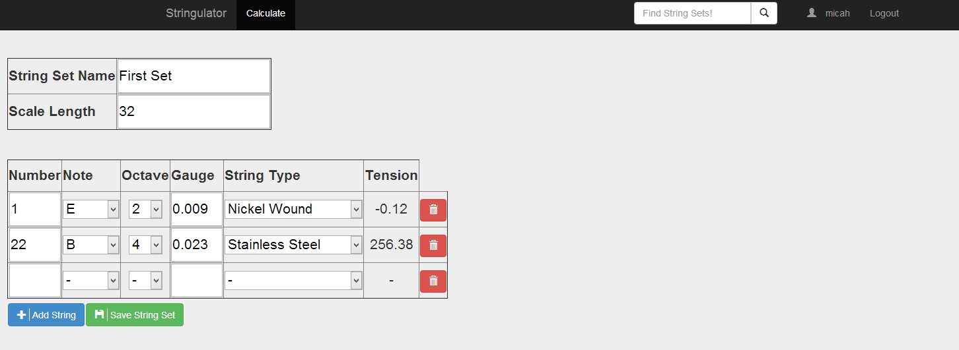

When a user logs in successfully they will be taken to their profile page.

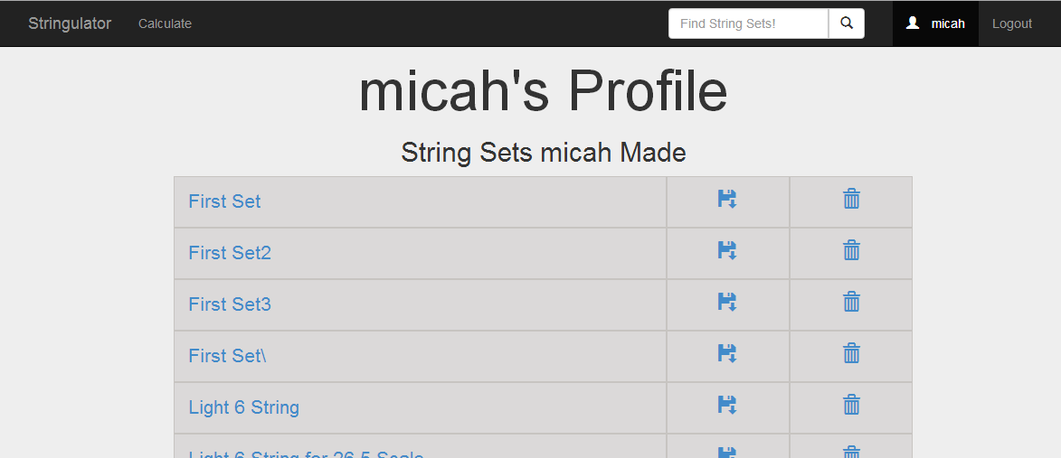

If a user does not log in successfully they will be told their login details are invalid on the accounts/invalid/ page.

A user can click the Logout button at any time to end their session or sign in as a different user.